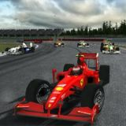
Xbox project – Newton’s laws
Your task: You will make a short film that uses Newton’s laws to explain car racing.

- Be in a group of four.

- Choose one person to be player and one person to be recorder.

- The player will play Formula 1 2010 on the Xbox
  - You can choose which driver you want to be
  - Choose either the Melbourne or the Montreal track
  - Choose to race one lap
  - The player gets to have one practice lap and one real lap
  - On the real lap, the recorder needs to record the lap on their laptop webcam via Adobe Premier Elements

- Use Adobe Premier Elements to add the following text to your film to explain the motion of the race car. You don’t have to add the text word for word in your film, but your text must contain the same scientific concepts. The text can be added in any order. Refer to “How to use Adobe Premier Elements to make a short movie” for more instructions on how to use Adobe Premier Elements.
Newton’s first law – When a car is stationary, it will remain stationary until a force acts on it. When the driver steps on the accelerator, a force acts on the car and the car moves.

The car will keep moving at the same speed and direction until a force acts on it. When the driver brakes or when there is too much friction on the road, the car will slow down or stop.

Newton’s second law is F = ma. The greater the mass, the greater the acceleration for the same force. F1 cars are designed to be light so that there is great acceleration for a small amount of force.

Newton’s third law - For every action there is an equal and opposite reaction

When the car accelerates, the motor and engine transfer force to the tires, which push backwards against the track. The track pushes back on the race car, causing the race car to move forward. When two forces push against each other, the less mass the object has, the faster it will move.

Instantaneous speed is the speed at a moment in time. It is the speed shown in the car’s speedometer.

Average speed is the speed for an entire journey. It is calculated by distance travelled divided by time.

Acceleration is when a car slows down, speeds up or changes direction.
How to use Adobe Premier Elements to make a short movie
Task: You are to make a short film on how fossils are formed. A movie will be provided to you showing how a fossil can form. The movie has no audio or captions. Your task is to add captions and audio to explain to other Year 9 and 10 students how fossils are formed.
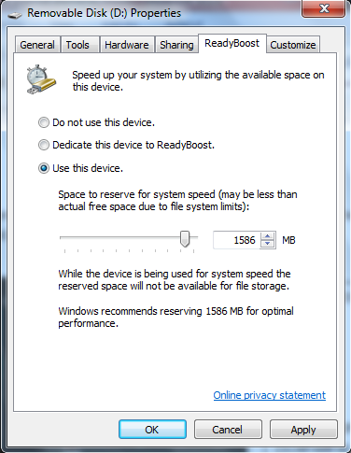
Before you start – get more RAM
Plug in a USB that has lots of free space. An Autoplay window will appear. Click on Windows Ready Boost. Click on Use this device then OK.
Tip: Save your work often!

Some quick info on Premiere Elements
The main window in Adobe Premiere Elements is called a Workspace. The diagram shows the names of different parts of the workspace.

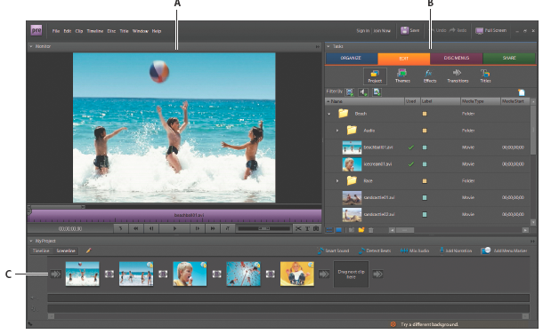
A = Monitor panel
B = Tasks panel
C = My Project panel (Sceneline view)

If you want more help, click on Help.

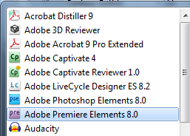
Getting started
- Open Adobe Premiere Elements by clicking on Start, All Programs and Adobe Premiere Elements. If this is the first time you open Adobe Premiere Elements, it may take a few minutes so be patient.

- Click on New Project.

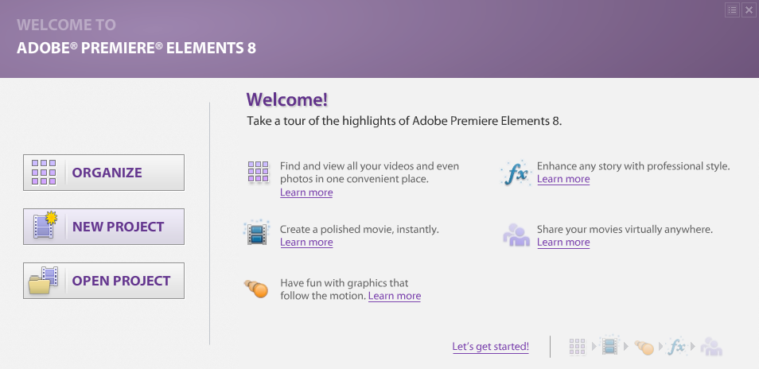

- You will be asked to save your project. Name your project “How fossils form” and choose an appropriate location on your laptop to save the project.

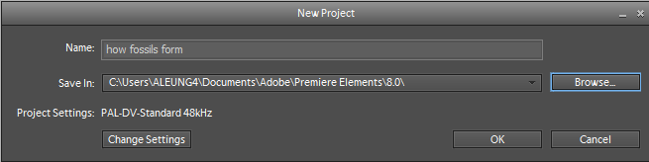
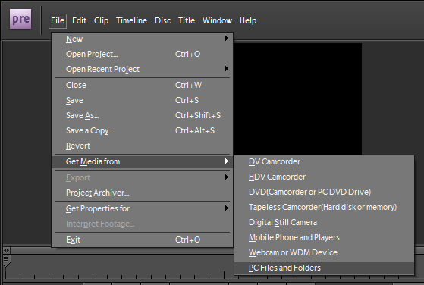
- You need to get the fossils video your teacher has provided you. Click on File, Get Media from and PC Files and Folders. Find the fossils video and load it into Premiere Elements.

- Click and drag the fossils video onto the scene line in the project panel.
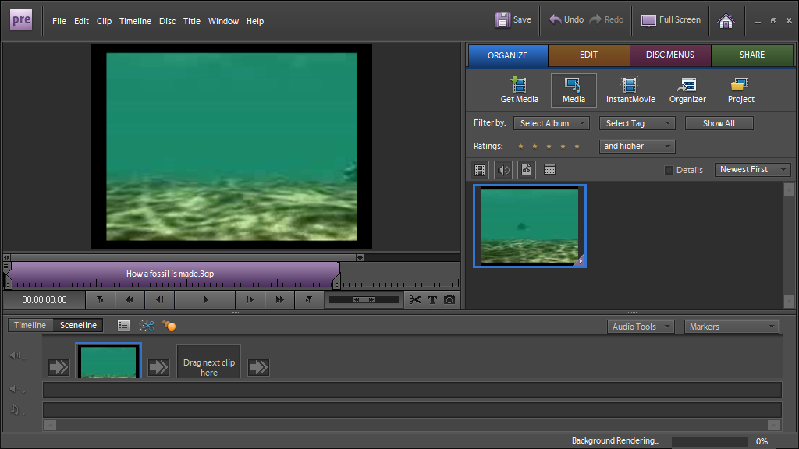
Click, drag and place video

Add a title to your film
- Click on Edit and Titles.
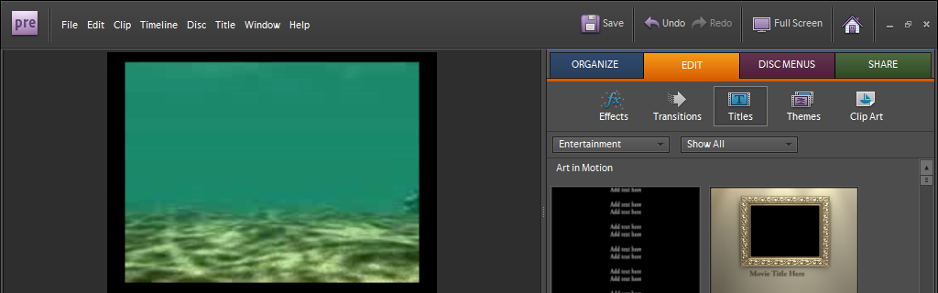

- Click on the title screen you like and drag it to an empty clip screen.

- Click on the Add default text tool to add a title for your movie.
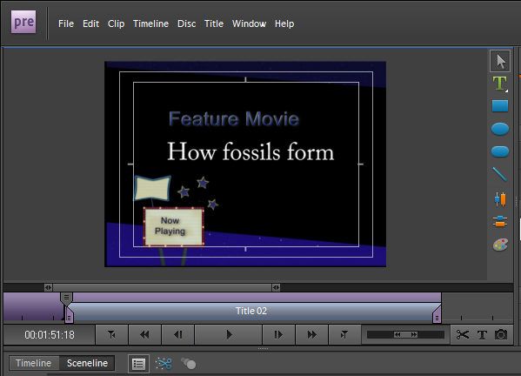
Add default text
You can click and drag the title frame in the sceneline to the start of the film.

Splitting clips
At the moment the fossils video is one continuous video. You will need to split the video so that you can add captions to explain different parts of the fossilisation process. You can split a clip at any frame.
- Select the fossils video clip in the Sceneline.

- Drag the current-time indicator in the mini-timeline of the Monitor panel to the frame where you want to create the split.

- In the Monitor panel, click the Split Clip button.
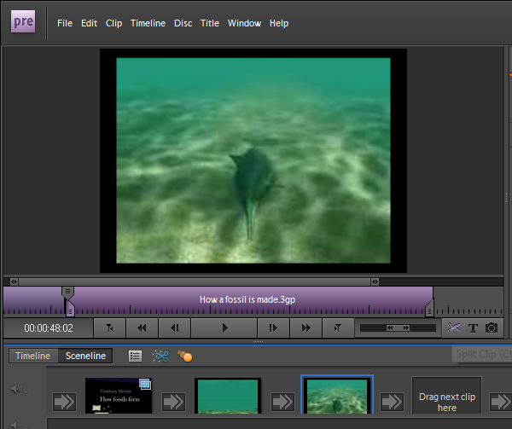
Split Clip button
Current-time indicator
Split the clip into different scenes that explain how a fossil can form.
Click on each scene and use the Add default text function to each scene to explain whether the scene shows a biotic or abiotic factor.
You can preview your film by clicking on Play.

Adding audio
- To add music to your film, go to File, Get Media from, PC files and folders and select a music file that is already on your laptop.

- Click and drag the music file to the Sceneline panel.

Saving and sharing your video
- Click on Share then Personal computer.
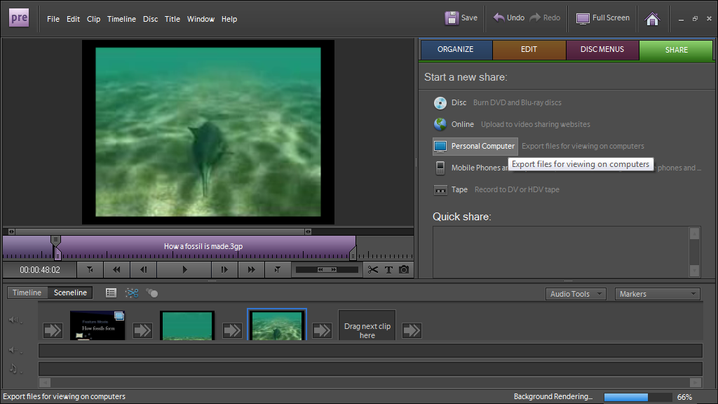
- Click on Adobe flash video, enter a title for your film and click on Save.

Congratulations! You have made your first short movie!

