NAME

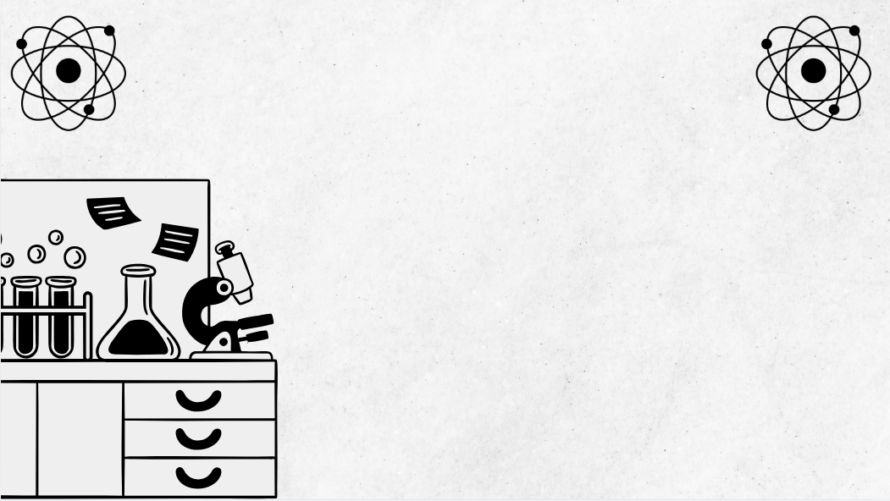 Band 5 and 6 students consistently demonstrate the appropriate use of precise terminology. This booklet will support you to do this.
Terminology for Chemistry
Module 1
Properties and Structure of Matter
Terminology for Chemistry: Module 1
Band 5 and 6 students consistently demonstrate the appropriate use of precise terminology. This booklet will support you to do this.
Term | Definition | Examples | Non-Examples | Diagram | Additional info (E.g. translation in first language)
Atom | The smallest unit of an element that retains the chemical properties of that element. | A single oxygen atom (O). | Two oxygen atoms bonded (O₂) is not a single atom.
Element | A substance that cannot be broken down into simpler substances by chemical means and contains only one type of atom. | Gold (Au) is an element. | Water (H₂O) is a compound, not an element.
Molecule | Two or more atoms bonded together. | An O₂ molecule. | A single helium atom (He) is just an atom.
Compound | A substance made by the chemical combination of two or more elements in fixed proportions. | Water (H₂O) is a compound of hydrogen and oxygen. | A mixture of sand and salt is not a compound.
Homogenous mixture | A mixture with uniform composition throughout. | Salt dissolved in water. | Salad (different visible components; not uniform).
Heterogenous mixture | A mixture where composition is not uniform throughout. | Sand and iron filings mixed together. | Air is a homogenous mixture (components are evenly distributed).
Evaporation | A technique separating a solute from the solvent. | Separating salt from saltwater. | Separating sand from water using a filter funnel.
Distillation | A technique separating liquids based on boiling points. | Separating water from saltwater and being able to collect both components. | Filtration (separation based on particle size, not boiling point).
Fractional distillation | Separation of a mixture of liquids with similar boiling points using a fractionating column. | Separation of petrol and diesel from crude oil. | Simple distillation for liquids with very different boiling points.
Separating funnel | A laboratory tool used to separate immiscible liquids by density. | Oil and water separation. | Filtration; separates by particle size.
Dissolve | The process where a solute mixes completely with a solvent, forming a solution. | Sugar dissolves in tea. | Sand in water does not dissolve; it settles.
Ion | An atom or molecule with an electrical charge because it gained or lost electrons. | Sodium ion (Na⁺). | Neon atom (Ne) is neutral, not an ion.
Cation | A positively charged ion. | Calcium ion (Ca²⁺). | Chloride ion (Cl⁻).
Anion | A negatively charged ion. | Chloride ion (Cl⁻). | Sodium ion (Na⁺) is a cation.
Isotope | Atoms of the same element with different numbers of neutrons. | Carbon-12 and Carbon-14. | Nitrogen and carbon are different elements, not isotopes
Electron configuration | The arrangement of electrons in an atom’s shells and subshells. | Sodium: 1s² 2s² 2p⁶ 3s¹. | “Sodium has two isotopes” is not electron configuration.
Electron shell | Energy levels surrounding an atomic nucleus where electrons reside. | Shells in sodium atom (1st, 2nd, 3rd). | The nucleus is not an electron shell.
Subshell | Subdivision of electron shells, grouped by orbital types (s, p, d, f). | 2p subshell in the 2nd shell. | The whole shell (combines  subshells)
Orbital | Region within a subshell where electrons are likely to be found (can hold two electrons). | 1s orbital in hydrogen atom. | The entire shell (contains several orbitals).
Periodic table | An organised chart of elements based on atomic number and chemical properties. | The modern periodic table. | A list of chemical compounds.
Group | A vertical column in the periodic table (elements share properties). | Group 1: Alkali metals. | Periods (horizontal rows).
Period | A horizontal row in the periodic table. | Period 2 includes lithium to neon. | Group 1 (vertical column).
Metal | Elements that are typically shiny, conduct electricity, and are malleable. | Iron (Fe) | Oxygen (O) – a non-metal.
Non-metal | Elements that don’t have metallic characteristics and tend to gain electrons. | Carbon (C) | Copper (Cu) – a metal.
Metalloid | Elements with properties between metals and non-metals. | Silicon (Si). | Sodium (Na) – a metal.
Covalent bond | A bond formed when atoms share pairs of electrons | Hydrogen gas (H₂). | Sodium chloride (NaCl), which has an ionic bond.
Ionic bond | Bond formed by transfer of electrons resulting in attraction between oppositely charged ions. | Sodium chloride (NaCl). | Water (H₂O) – consists of covalent bonds.
Metallic bond | Bond where electrons are shared among a lattice of metal atoms (delocalized electrons). | Copper wire | Covalent bonds in diamond.
Lattice | A regular, repeating arrangement of atoms, ions, or molecules in a solid. | NaCl crystal lattice | Amorphous solids (like glass) do not have a lattice.
Valency | The number of electrons an atom can lose, gain, or share during bonding. | Oxygen has a valency of 2. | Atomic mass is not valency.
Electronegativity | Atom’s ability to attract electrons in a bond. | Fluorine is highly electronegative. | An atom’s charge is not electronegativity.
Atomic radius | Distance from nucleus to outermost electron shell. | Caesium has a larger atomic radius than hydrogen. | Ionisation energy is not atomic radius.
Ionisation energy | Energy needed to remove an electron from a gaseous atom. | Helium has a high ionisation energy. | Electron affinity (adding, not removing, an electron).
Electron affinity | Energy change when an atom gains an electron. | Chlorine releases energy forming Cl⁻. | Ionisation energy (removing an electron).
Intermolecular forces | Forces between molecules influencing physical properties. | Hydrogen bonds in water. | Covalent bonds (within molecules).
Dipole-dipole | Attraction between polar molecules’ positive and negative ends. | HCl molecules attract each other by dipole–dipole forces. | Dispersion forces, which act in non-polar molecules
Dispersion forces (London forces) | Weak intermolecular forces from temporary electron fluctuations in all atoms and molecules. | Attractions between noble gas atoms (argon). | Hydrogen bonds are much stronger than dispersion forces.
Polar | Molecules with uneven electron distribution, resulting in positive and negative ends. | Water (H₂O) is polar. | Methane (CH₄) is non-polar
Non-polar | Molecules with even electron distribution and no charge separation. | Methane (CH₄) is non-polar. | Water (H₂O) is polar.
Linear | Molecular shape with atoms in a straight line. | Carbon dioxide (CO₂) is linear. | Water (H₂O) is bent.
Tetrahedral | Molecular shape with four atoms at the corners of a tetrahedron around a central atom. | Methane (CH₄) is tetrahedral. | Carbon dioxide (CO₂), which is linear.
Trigonal planar | Shape with three atoms around a central atom in one plane (120° angles). | Boron trifluoride (BF₃) is trigonal planar. | Methane (CH₄) is tetrahedral, not trigonal planar.
Trigonal pyramidal | Shape with three atoms bonded to a central atom and a lone pair, resembling a pyramid. | Ammonia (NH₃). | BF₃ (trigonal planar, not pyramidal)
Bent | Molecular shape where atoms are at an angle due to lone pairs on central atom. | Water (H₂O) is bent. | CO₂ (linear, not bent).

