NAME

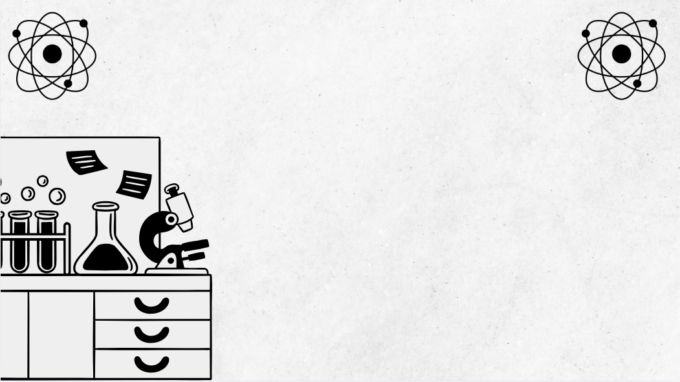 Band 5 and 6 students consistently demonstrate the appropriate use of precise terminology. This booklet will support you to do this.
Terminology for Chemistry
Module 2
Introduction to Quantitative Chemistry
Terminology for Chemistry: Module 2
Band 5 and 6 students consistently demonstrate the appropriate use of precise terminology. This booklet will support you to do this.
Term | Definition | Examples | Non-Examples | Diagram | Additional info (E.g. translation in first language)
Mole | Unit for amount of substance (6.022 × 10²³ particles). | 1 mole C = 6.022 × 10²³ atoms | 1 mole of apples (not atomic/molecular entities)
Molar Mass | Mass of one mole of a substance (g/mol). | H₂O = 18.02 g/mol | Atomic number of O (8); not mass per mole
Avogadro’s Number | The number of particles in a mole (6.022 × 10²³). | 1 mole NaCl contains 6.022 × 10²³ formula units | 1,000 atoms (not a mole)
Atomic Mass Unit (amu) | 1/12 mass of carbon-12 atom; expresses atomic/molecular mass. | H = 1.007 amu | 1.007 g is not 1 amu
Stoichiometry | Quantitative relationships between reactants/products in an equation. | Calculating H₂O from 2H₂ + O₂ → 2H₂O | Just describing colour change
Conservation of Mass | Mass not created/destroyed; reactant mass = product mass. | Captured mass of candle burning products matches start | Assuming mass disappears
Balanced Equation | Equal numbers of each atom type both sides of equation. | 2H₂ + O₂ → 2H₂O | H₂ + O₂ → H₂O (unbalanced)
Empirical Formula | Simplest whole-number ratio of atoms in a compound. | CH₂ as empirical for C₂H₄ | C₂H₄ (not simplest ratio if reducible)
Molecular Formula | Actual number of atoms of each element in molecule. | Glucose: C₆H₁₂O₆ | CH₂ is empirical, not molecular formula for glucose
Percentage Composition | Percent by mass of each element in a compound. | H₂O: ~11.1% H, 88.9% O | Percent by volume, not mass
Concentration | Amount of solute per unit volume solution. | NaCl 2M = 2 moles/L | Temperature of solution
Molarity | Moles of solute per litre of solution (mol/L). | 1.0 M NaCl = 1 mole/L | 50% sugar solution by mass
Dilution | Lowering concentration by adding solvent. | Add water to 2M solution → 1M | Removing solute, not solvent
Limiting Reactant | Reactant used up first, limits product formed. | B runs out first in 2A + B → C | Reactant present in excess
Excess Reactant | Reactant left over after reaction finishes. | A leftover if B is limiting in 2A + B → C | Limiting reactant
Theoretical Yield | Calculated maximum product from given reactant. | Predicting 10 g product | Actual yield (measured, may differ)
Actual Yield | Real measured product obtained in experiment. | 8 g obtained in lab | Theoretical, calculated yield
Percent Yield | Ratio actual yield/theoretical yield × 100%. | 8 g actual, 10 g theoretical: 80% yield | Actual yield in grams
Significant Figures | Digits reflecting precision and certainty. | 3.40 (three significant figures) | “3”, if precise to 0.01 g
Density | Mass per unit volume (g/cm³ or g/mL). | Water ~1.00 g/cm³ | Molarity (moles per litre, not mass per volume)
Molar Volume | Volume of 1 mole gas at STP (22.4 L/mol). | N₂ gas occupies 22.4 L at STP | Liquid water at 1 mole
Ideal Gas Law | PV = nRT relates gas pressure, volume, moles, temperature. | Calculate pressure for gas sample | Liquid behaviour not following PV=nRT
Gram Formula Mass | Sum of atomic masses in formula (g/mol). | H₂O: 2×1.008 + 16.00 = 18.02 g/mol | Using atomic number for mass
Percent Purity | Percentage of sample that is pure substance. | 90 g CaCO₃ in 100 g sample = 90% pure | Assuming entire sample is pure
Normality | Gram equivalents per litre solution; concentration ref. reactivity. | 1N HCl: 1 equivalent/L | Molarity (does not consider equivalents)
Conversion Factor | Ratio for converting units (e.g. mass↔moles), equal to one. | 1 mole/6.022×10²³ particles | Adding numbers without units
Mole Ratio | Ratio of moles from balanced equation. | 2H₂ + O₂ → 2H₂O; ratio H₂:H₂O = 1:1 | Comparing masses not moles
Unit Conversion | Changing measurement to new unit using conversion factor. | 1000 mL = 1 L | Changing value w/o unit change
Back Titration | Analytical method: excess reagent reacts w/analyte, leftover is titrated. | Excess acid titrated after reaction w/insoluble base | Direct titration
Serial Dilution | Stepwise dilution, same factor each step. | 1 mL to 9 mL, repeat for series of 1:10 dilutions | Adding lots of water at once (not stepwise)

